Final Project: Revisiting Sukhantar, et al, “Policing in Patriarchy: An experimental evaluation of reforms to improve police responsiveness to women in India”: Replication of the Reporting Impact Findings and Exploring Key Drivers of Police Attitudinal Shifts

Elizabeth Bader and James Schorr

Boston College

MESA 8410

November 26, 2024

Sukhtankar et al’s “Policing in Patriarchy” study evaluates the impact of the introduction of Women Help Desks (WHD) in police stations on reporting and registration levels of gender-based violence cases against women in India. The under-reporting of gender-based violence (GBV) in patriarchal societies is widespread and gender-targeted police reforms have had mixed success in improving police responsiveness to women. Multiple studies have documented the societal barriers and stigmas contributing to the lack of reporting and access to police services for women in India. A paper[1] by Singh and Attarwal revealed the feminine ideal which women are expected to attain and the violence they supposedly deserve if they do not maintain this ideal. Supporting this finding was a study[2] by Dhanaraj, et al, which described “female guilt”: that women sometimes believe that they deserve violence for violating Indian female ideals, which increases male violence toward women in a self-perpetuating cycle. Another study[3] by Patel, et al, showed that attempts to increase gender equality have included reserving political positions for women, which has had limited success and mostly allows for “token women” because of the prevailing patriarchal deeply held beliefs. In the “Policing in Patriarchy Study”, Sukhtankar et al implemented a large, randomized control trial, instituting WHDs in 120 treatment stations and tracked formal reporting of GBV case levels in those stations for comparison against a set of 60 peer control stations where WHDs were not instituted.

Key findings from the “Police in Patriarchy” study included:

1. The WHD intervention led to an increase in the registration of women’s cases, specifically:
   * The increase, comparing treatment over control stations, in Domestic Incident Reports (DIRs), was statistically significant.
   * The increase, comparing treatment over control stations, in First Information Reports (FIR), which implements formal criminal case investigations and proceedings, was statistically significant but entirely driven by women-run WHDs.
2. Over the course of the intervention, there was no significant change in police officer attitudes and beliefs regarding their own effectiveness in handling women’s related cases, their helpfulness in supporting women victims and the level of attention paid to women’s related cases.

For our final project, we further examined these key findings with data provided by the authors to 1) validate the increase in reporting and registration levels among WHD and 2) determine if changes in police sensitivity over the course of the study varied across characteristics of participating police stations.

Specifically, our research focused on the following areas:

* **Research Track #1: Validation of the Impact of WHD on Reporting and Arrest Levels** 
  + Questions addressed:
    - Is the presence of a WHD effective at increasing the reporting and arrest levels for women’s related cases as measured by FIR, DIR, arrest counts?
    - Is there a significant difference in the reporting and arrest actions between women-led WHDs and regular WHDs (as measured by FIR, DIR, arrest counts)?
  + Rationale:
    - If the “Police in Patriarchy” findings are replicable, they can further justify policymaker budget investments in formally instituting WHDs system-wide at police stations, with particular investment on expanding women-run WHDs.
* **Research Track #2: Identifying Station Level Drivers of Police Sensitivity Towards Crimes Against Women** 
  + Questions addressed:
    - Are police station characteristics (size, geographic type, and employee mix) associated with changes in police officer sensitivity towards crimes against women?
  + Rationale:
    - The “Police in Patriarchy” study determined no change in police sensitivity over the study. By further examining if variability in attitudinal shifts exists for certain station characteristics, policy makers can focus future training and awareness programs on station types most aligned to persistent, negative gender attitudes (i.e., limited government budget and resources can be focused on station types where gender bias is likely to be concentrated).

**Research Track #1: The Steps in the Data Science Lifecycle for the Validation of the Impact of WHD on Reporting and Arrest Levels**

Overview of Data Sources and Initial Findings

To address research questions in track #1, we used the data set “admin_wide data.dta”, described in the table below.

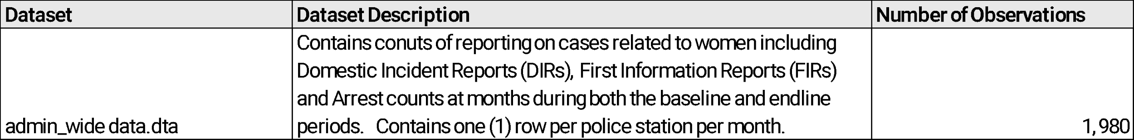

Data Preparation and Exploratory Data Analysis

There were no missing values in the dataset. To answer the key questions in track #1, we focused on the endline period in the data (May 2019 to Dec 2020) and focused on average monthly reporting volumes for cases related to women in the treatment and control groups. Within the treatment group, we also investigated the average monthly reporting volumes by women run help desks and regular (non-women led) help desks. We calculated monthly reporting averages per station of DIR, FIR, and Arrest counts and found consistency with the authors’ findings (i.e., treatment stations observed higher levels of reporting of women related cases, relative to the control.)

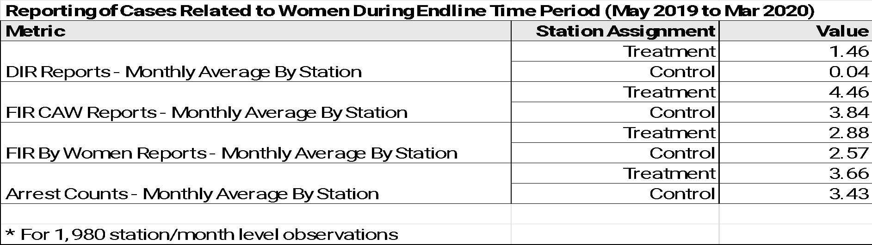

In addition to the overall means (across the endline time-period), we were able to replicate the monthly time-series found in the “Police in Patriarchy” study. The exhibits below show the consistency in DIR reporting findings from the original study (exhibit on the left below) and in our exploratory analysis (exhibit on the right) for overlapping time periods post intervention launch.

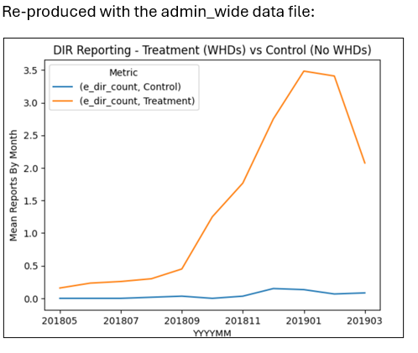

A visual inspection of the time series of reporting volumes by month also aligns with the study findings of increases in FIR CAW and FIR By Women reports in treatment stations versus controls.

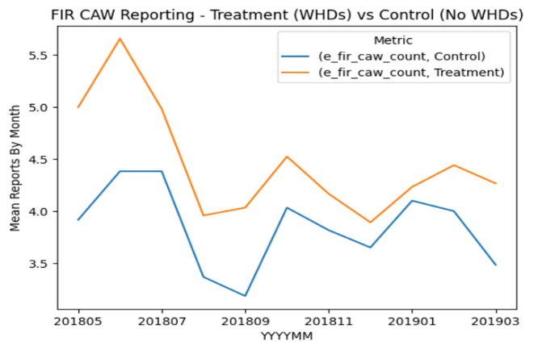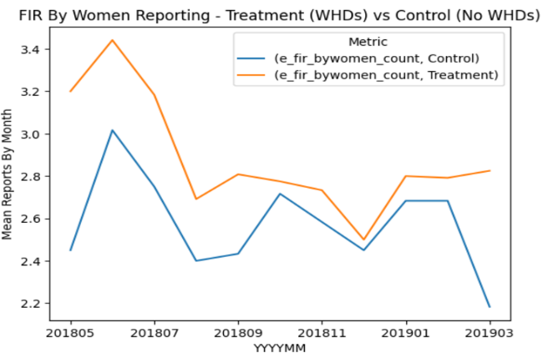

Pivoting to the examination of women-run WHD vs. regular WHD, our exploratory data analysis results also aligns with the study findings of minimal difference in DIR reporting between the women-run WHD and regular WHDs, but higher reporting of FIR CAW, FIR by Women and Arrests in women-Run WHD when compared to regular WHD (within the treatment group). A value of 1.0, reflected in the orange lines in the exhibits below, represent women-run WHDs counts (while the blue line represents counts for the regular WHDs).

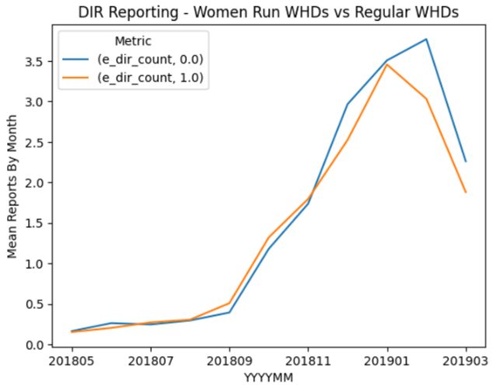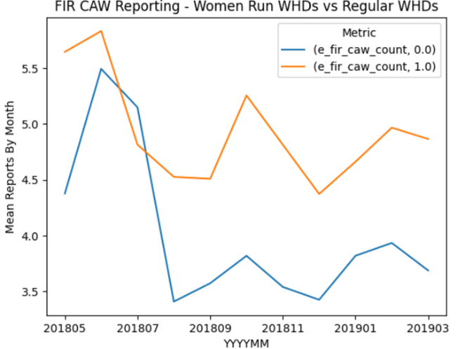

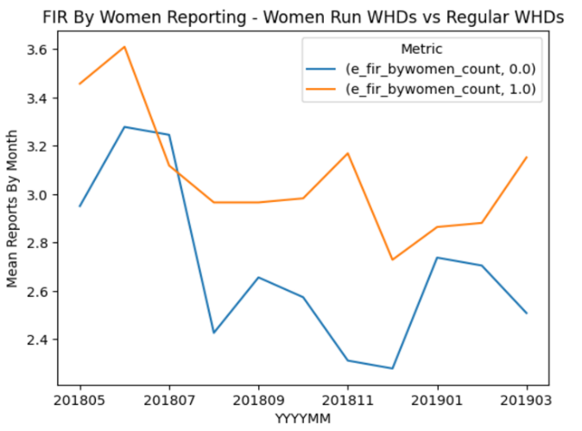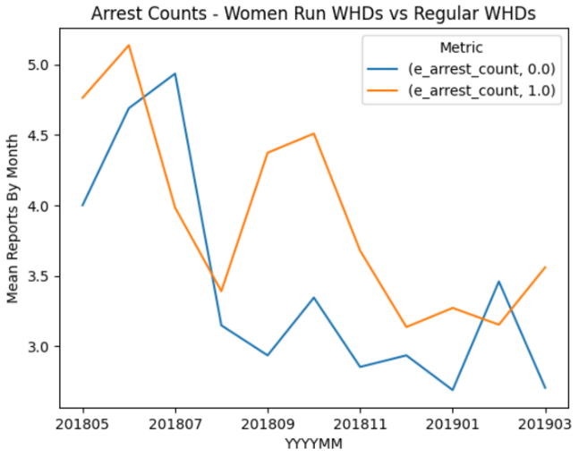

Modeling and Hypothesis Testing Results

To more formally assess the visual differences and trends observed during the exploratory analysis phase, we conducted a series of statistical tests to further validate the consistency of our findings with the original study. Specifically, we ran a series of t-tests to evaluate if station monthly reporting volumes, over the endline time periods, were significantly different across the treatment and control groups stations and separately, for women-run vs. regular WHDs (within the treatment population). The tables below contain the results:

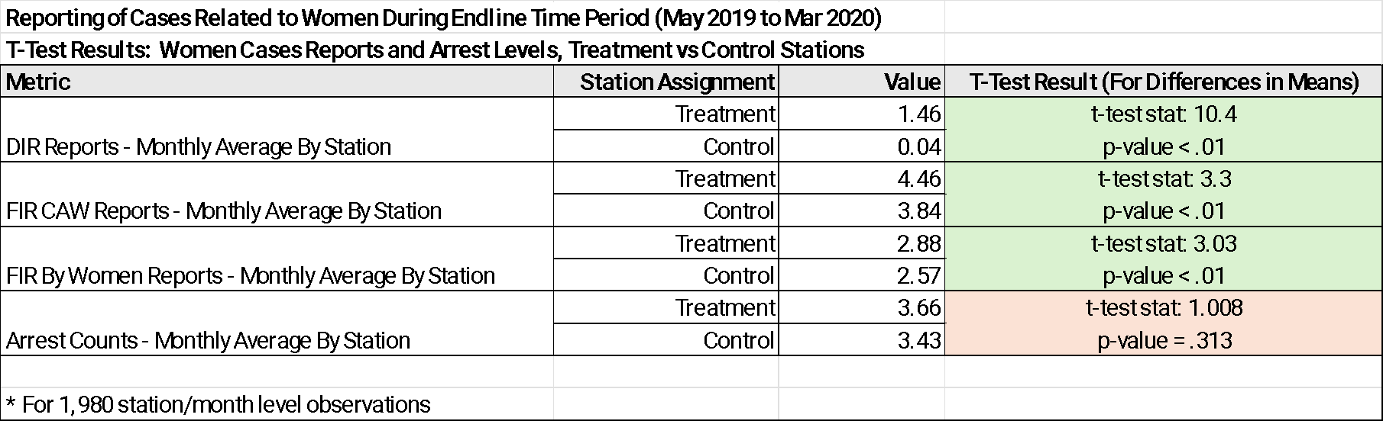

The table above validates the original study findings with statistically significant higher reporting volumes of DIR, FIR CAW, and FIR By Women reports in treatment stations when compared to controls.

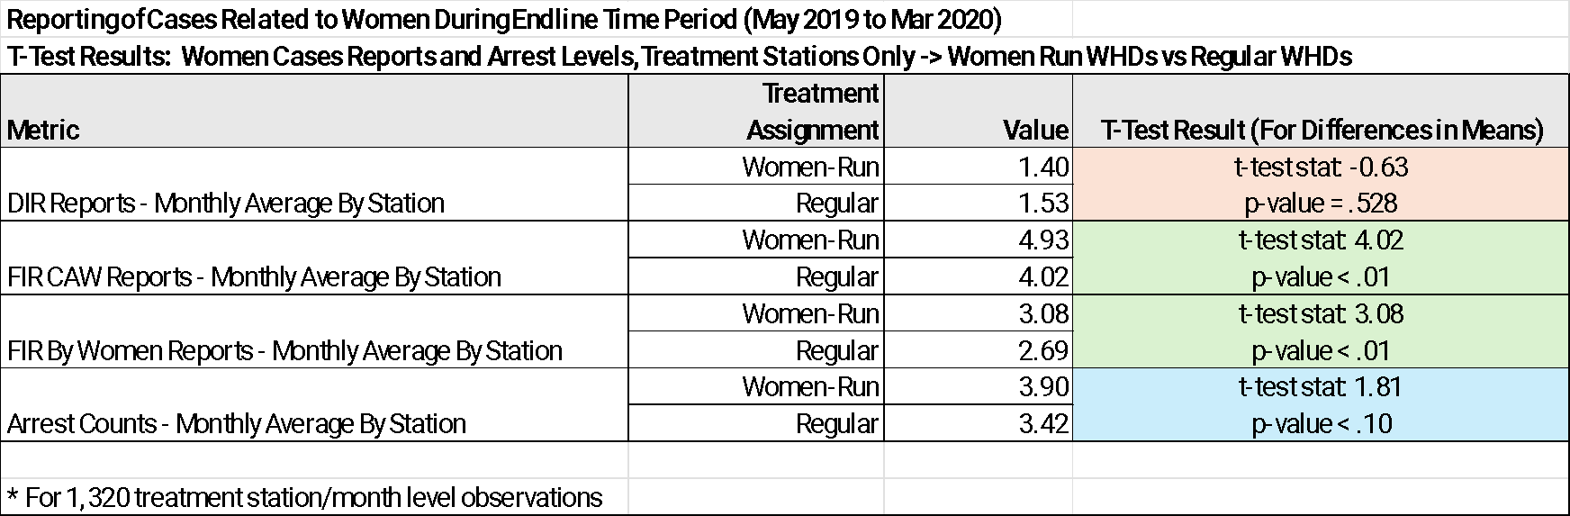

The table above validates the original study findings with statistically significant higher reporting volumes of FIR CAW and FIR By Women reports in women-run WHD stations when compared to regular WHD stations. Consistent with the original study, we also found that monthly arrest counts are higher at women-run WHD stations with a p-value of 0.07, depicting a ‘directional’ finding that will need validation with future research.

Our overall results come to the same conclusion as the research by Suktankar, et al, that women’s help desks promote women’s willingness to report gender-based violence.

**Research Track #2: The Steps in the Data Science Lifecycle for Identifying Station Level Drivers of Police Sensitivity Towards Crimes Against Women**

Overview of Data Sources and Initial Findings

The datasets leveraged for this track are documented in the table below:

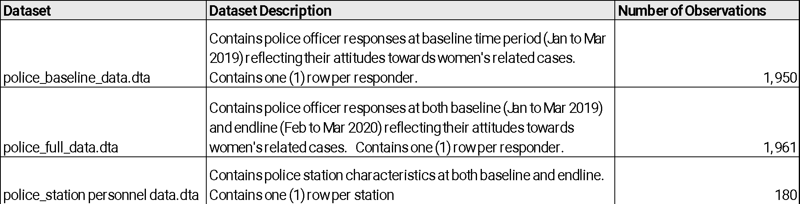

Key attributes examined from the survey data assets included responses to questions on the police attitudes around effectiveness, helpfulness, attention, and staffing required to improve police responsiveness to women’s related cases. A ‘sensitivity score’ for each responder, derived by the study authors, was also analyzed (a higher score indicating more sensitivity expressed by the respondent to women related cases).

An examination of the distributions of police responses to key survey questions at baseline and endline confirms the pervasive, strong beliefs by police that they are highly responsive and sensitive to women related cases, with limited to no change in those convictions over the course of the study (see the table immediately below).

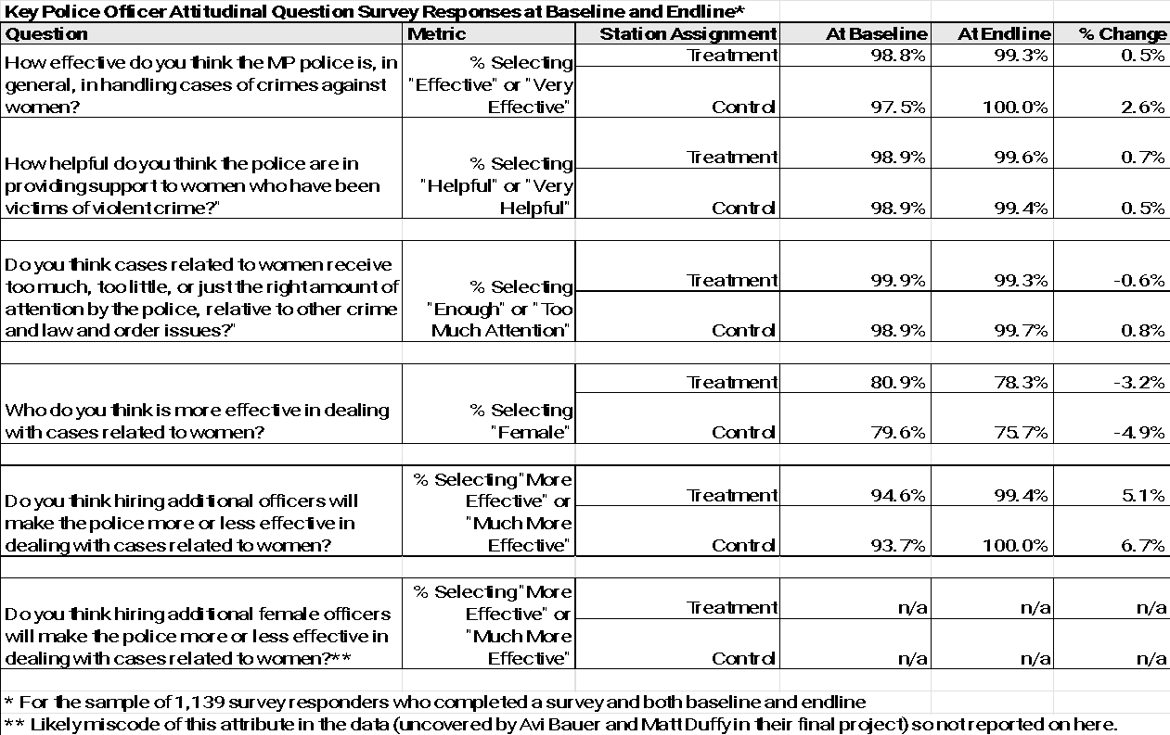

In addition to the survey responses, the sensitivity score provided by the authors had little change from the baseline to endline, across the treatment and control groups in line with the “Policing in Patriarchy” study findings.

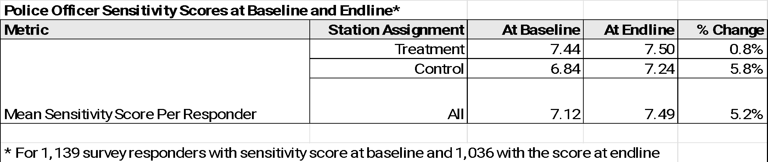

The station level data exhibits the low level of female employment in the police force.

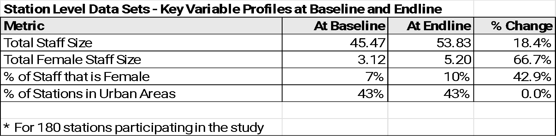

Data Preparation and Exploratory Data Analysis

We combined the survey and police station data assets into two (2) datasets for further exploratory data analysis and to perform modeling to assess the relationship between police sensitivity and station characteristics.

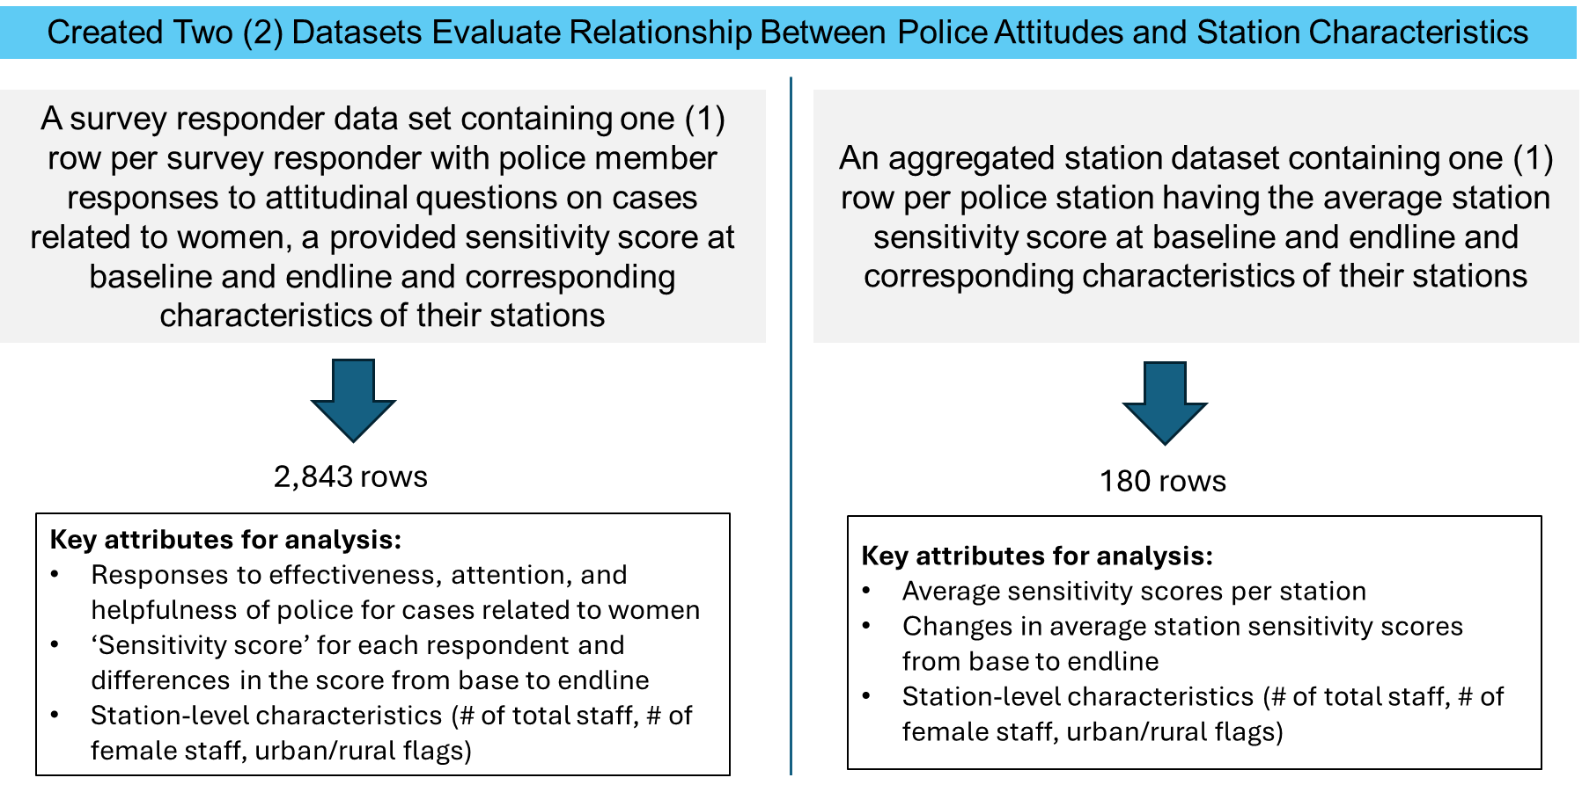

Having two distinct datasets for the analysis allowed for more complete evaluation of the relationship between attitudes and station characteristics. Should there be consistency in findings across both datasets, it provides a higher degree of confidence in the findings (and vice versa should the separate analyses provide confounding or competing results).

For the analysis, we created a “sensitivity difference” metric, calculated as the difference between the endline and baseline sensitivity scores, (endline – baseline sensitivity) housed in each dataset. Exploratory data analysis on both data sets showed limited signal on relationship between the sensitivity difference and station characteristics. The exhibit below (using the station level dataset, n=180) shows the minimal change in sensitivity scores over the course of the study and is reflective of the lack of clear relationship between changes in police sensitivity and station characteristics found in the responder dataset as well (see “2 - Track 2 - EDA.ipynb”).

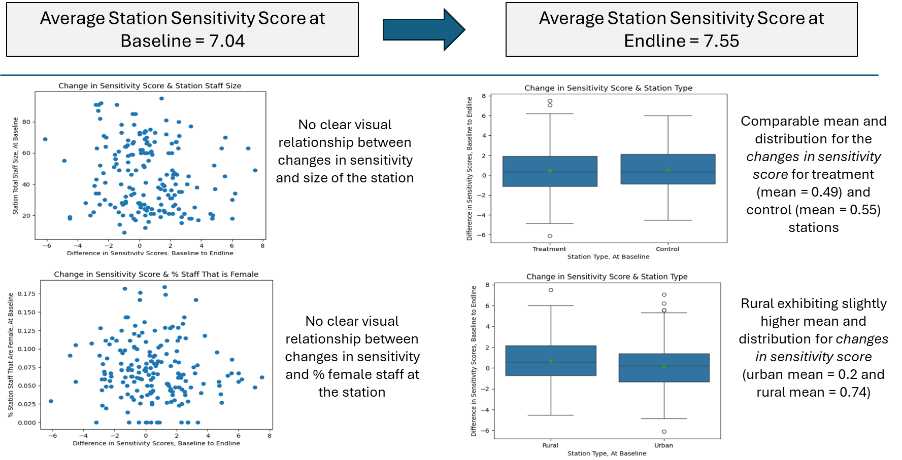

Modeling and Hypothesis Testing

Leveraging both of the datasets, we ran a series of linear models to examine the relationship between changes in the sensitivity score and four (4) station characteristics as follows:

*Sensitivity_diff = f (station size, % of staff that are female, station type: 1=urban, 0=rural, and station study group: 1=treatment, 0=control)*

The model results confirm a lack of relationship between the variables. All of the models have extremely low R-squared values, indicating poor fits. The person level models did indicate a negative relationship between station size (i.e., number of police officers assigned to the station) and changes in police sensitivity, but that finding was not replicated with the station level dataset models. All the other variables were insignificant across the model fits, so we can’t say with confidence that a relationship between station characteristics and improvements in police sensitivity exists.

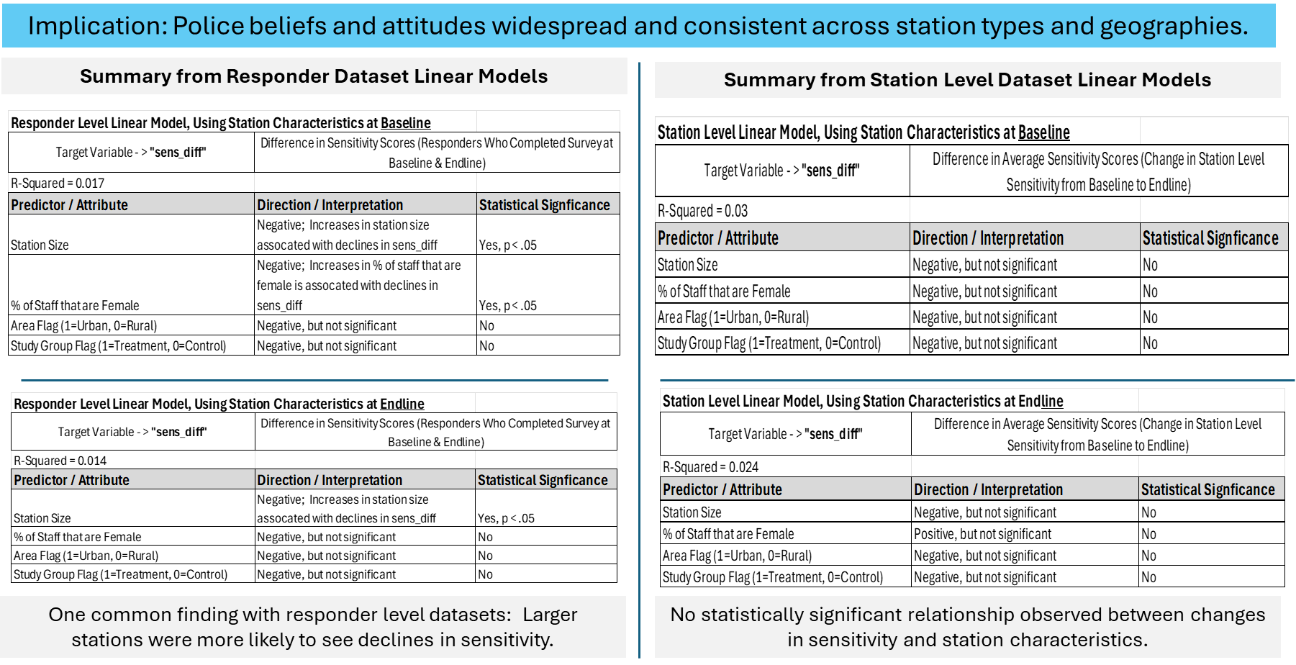

Discussion

Our results validated the original study’s findings with respect to the effectiveness of women’s help desks. In addition, our results detected no specific relationship between station characteristics and police sensitivity. With these results in mind, policy makers should focus funding on the presence of women’s help desks but do not need to focus, necessarily, on particular stations. In replicating the study, we ran into challenges understanding the data sets. Initially, we did not recognize the differences between months tagged with the same label but actually being in different years. This made the initial versions of our track one data explorations and models inaccurate. A lesson learned here is the importance of thoroughly understanding the original data sets and the original study, seeking to discern the subtleties indicated by the study authors. Additionally, we recalled the importance of attempting to check one another’s work. We also struggled in our use of statistical analysis. It was tricky to decide which tests to use on which types of questions. This was certainly a growing area and requires further growth. In all, we found this project to be a thorough (and welcome) stretch of our capabilities.

References

Dhanaraj, Sowmya; Mahambare, Vidya. "Male Backlash and Female Guilt: Women's Employment and Intimate Partner Violence in Urban India." *Feminist Economics* (2022) 28: 170-198.

Patel, Taran; Romani, Laurence; Ramasamy, Chandra; Oberoi, Poonam. "Gender role encapsulation as resistance to patriarchy: Women politicians' work and gender equality in India." *Organization* (2021) 30: 307-325. 1 March 2021.

Singh, Sanjay; Aggarwal, Yogita. "Are Traditional, Negative Gender Attitudes Associated with Violent Attitudes Toward Women? Insights from a New, Culturally Adapted Measure in India." *Sex Roles* (2020) 83: 143-162. Springer Science+Business Media, LLC, part of Springer Nature 2019. 27 November 2019.

Sukhtankar, Sandip; Kruks-Wisner, Gabrielle; Mangla, Akshay. “Policing in patriarchy: An experimental evaluation of reforms to improve police responsiveness to women in India.” *Science* (2022) 377: 191-198. 8 July 2022.

1. Singh, Sanjay; Aggarwal, Yogita. "Are Traditional, Negative Gender Attitudes Associated with Violent Attitudes Toward Women? Insights from a New, Culturally Adapted Measure in India." Sex Roles (2020) 83: 143-162. Springer Science+Business Media, LLC, part of Springer Nature 2019. 27 November 2019.
2. Dhanaraj, Sowmya; Mahambare, Vidya. "Male Backlash and Female Guilt: Women's Employment and Intimate Partner Violence in Urban India." Feminist Economics (2022) 28: 170-198.
3. Patel, Taran; Romani, Laurence; Ramasamy, Chandra; Oberoi, Poonam. "Gender role encapsulation as resistance to patriarchy: Women politicians' work and gender equality in India." Organization (2021) 30: 307-325. 1 March 2021.